# Wearable project

Arron Dick

Concept of this project was originally to have a suit with NeoPixels down the legs and arms that would flash in-time to ambient music to produce interesting displays.

Over the course of doing this project I have severely scaled it back to one line of 10 NeoPixels down the front of a vest due to money and time constraints.

The project works by input being received from a microphone and that value(from 0-1023 but usually more like 300-400) being chosen to compute a colour. These values are stored in an array so that the road like effect can be displayed.

I would expand this with additional lines of NeoPixels and different effects, I originally wanted something a bit similar to an equalizer in terms of visual effect but that requires pre-processing audio files, not picking up a volume level from a microphone.

## Fritzing diagram

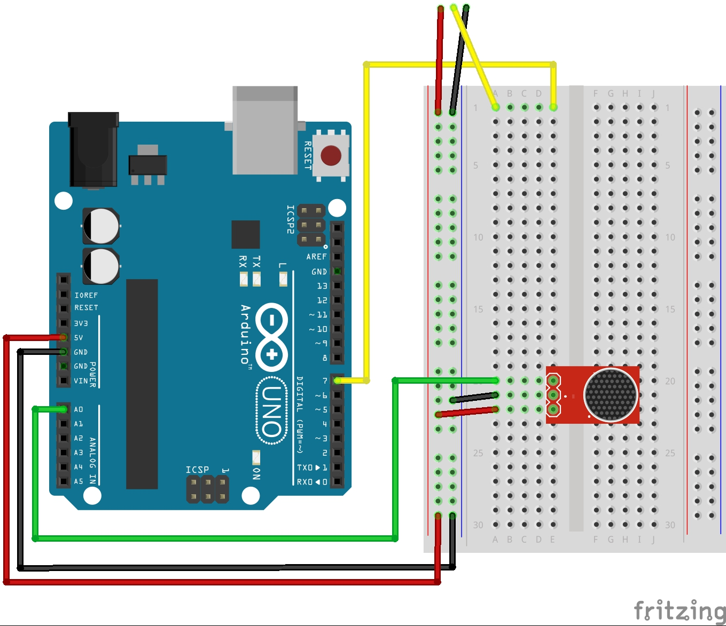

## Schematic

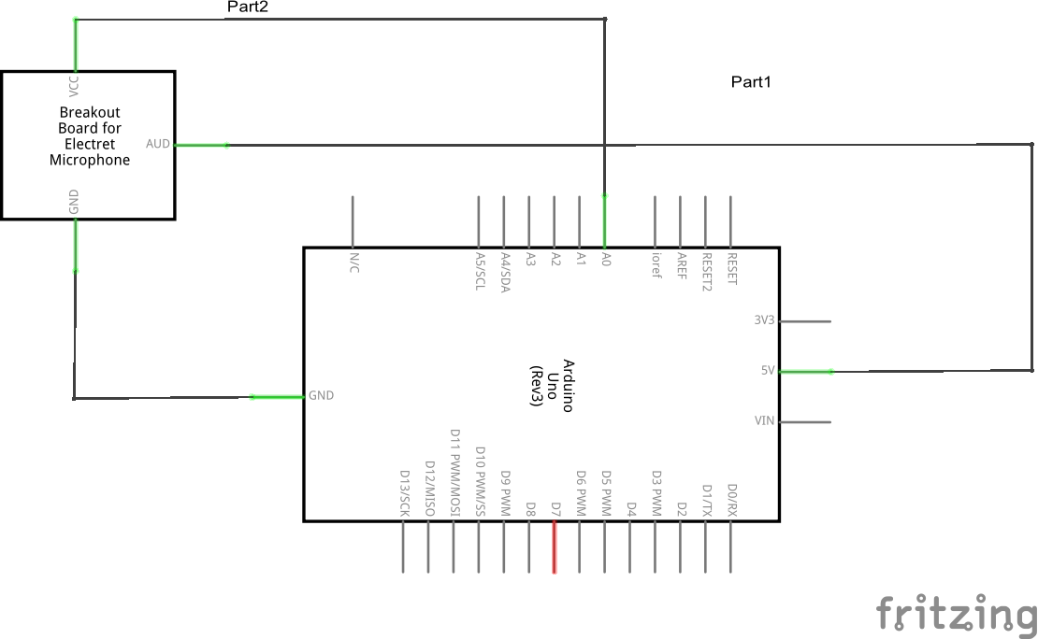

Not shown is the NeoPixel strip as I couldn’t find a component for it

## Video

http://dickaj1embedded.blogspot.co.nz/2015/05/wearable-video.html